Curtis Banks, CEO
Money Smart Education, LLC

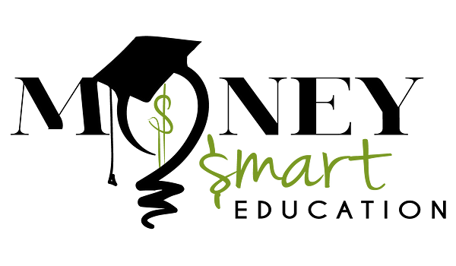

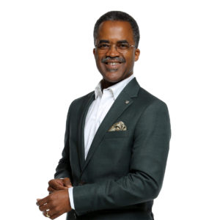

Curtis is an award-winning author, speaker, investor, and business consultant. He is certified as a mentor, coach and mastermind facilitator. Curtis holds a Bachelor’s degree in Computer Science, Masters in MIS, and completed the Wharton's Executive Finance Program.
He has 37 years of leadership experience with The Boeing Company. Responsibilities ranged from Technical, Managerial, & Executive positions. Curtis formed and led the Boeing Information Technology Global Diversity & Inclusion Council. He focuses on creating clear personal & business objectives, team alignment, and creating value for stakeholders.
Curtis is passionate about education, mentoring, leadership development, and building high performance teams. Specializing in personal and organization leadership strategies for businesses of all sizes. Curtis' 6 Step Leadership Blueprint has taken clients to both personal and business success. He teaches strategies to help you achieve life balance and have more success in life.
Curtis is the author of “The Book on Money Management - How to Build a Foundation for Wealth” and the CEO of Money Smart Education, LLC.
Curtis enjoys time with his family, reading, writing, billiards, playing the ukulele, traveling, and sightseeing.
Website: www.MoneyManagementBook.com
E-mail: Curtis@MoneySmartEducation.com

