DENETRIS RENÉGODBOLD-ANDERSON
Board Member

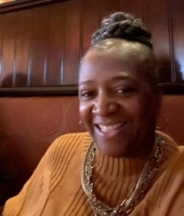

Professional and Educational Background
- René is a Retired School Administrator, Assistant to The Area Superintendent, Curriculum Specialist, High School principal and teacher with the Cleveland Municipal School District for over 37 years.
- Cleveland State Graduate-M.S., Ohio State University Alumni- B.S., John Adams High School graduate, Cleveland, Ohio

Religious and Community involvement
- René serves as Chairperson of The Trustees Ministry at Memorial Baptist Church, Cleveland, Ohio.
- Performing Arts Director and Audio-Visual Ministry at Memorial Baptist Church, Cleveland, Ohio

She Coordinates the “Blessing Box food giveaway in the Mt. Pleasant Community. She also maintains a community Lending Library in the Cleveland Heights/University Heights community.

Personal Connection
René has known Andre Brown and his family since he was a young boy. They became part of her extended family. In addition, Mario, the young man who was also murdered with him, was one of her former students. René, the proud mother of 2, grandmother of 2 and Godmother of 10, cannot imagine losing one of her children to unnecessary gun violence, or the pain that this kind of tragedy brings. This is why when asked to join this board, Rene accepted.

René confesses that God has blessed her with so much that she feels she must share her gifts to help others. She feels deeply connected to this organization’s cause and call for justice. “Those responsible for the murderer of Andre and Mario must be brought to Justice!”

