JONATHAN DUNCAN
Board Member

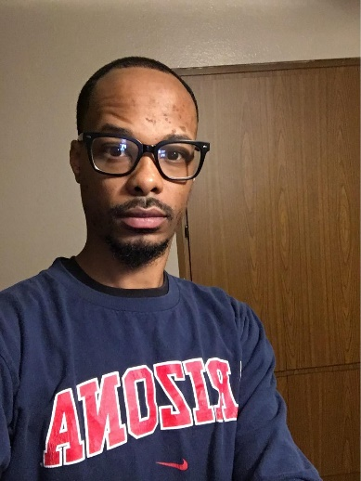

Jonathan was born on the East side of Cleveland and grew up in the South Collinwood neighborhood where he met his dear friend and spiritual brother, Andre A. Brown. They attended the same middle school and high school. They became very close friends and knew each other very well. Andre’s untimely loss of life due to unnecessary gun violence has not just left a hole in Jonathan’s life, it has given him a royal purpose. Jonathan fights for justice for Andre and others whose unresolved homicide leaves family and friends left behind to morn their loved one’s tragic ending.

Jonathan now resides in Phoenix, Arizona where he works as a Sorter Operator for Runbeck Election Services since 2020. Jonathan enjoys learning, reading, cooking, trading and traveling.

Jonathan believes his role in M-PAC Cleveland is to help bring our Mission Statement for justice to reality. Being attentive to every duty placed upon him is where he knows he will be effective. This includes participating in events in Cleveland when he can. Jonathan is committed to keeping the name and spirit of Andre A. Brown alive.

