MICHELLE BELL
Founder, MPAC Cleveland
Surviving Our New Normal

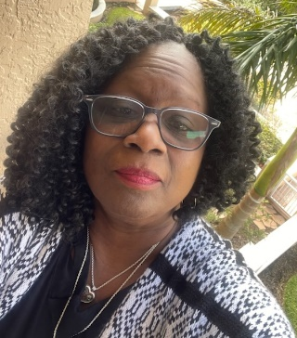

Michelle grew up in the inner city of Cleveland, Ohio so she is no stranger to this community’s growing problems and needs. Early in life she decided to be a part of the solution. College and service activism were on the top of her list.

Beyond and above her academic training, credentials and humble accomplishments which include MBA with distinction in Accounting and Program Management, educator, and award-winning leader, she is a faithful believer and servant of God. Moreover, her compassion for her fellow man is grounded in her Christian duty and obligation to love my neighbor as I love myself according to Matthew 22:36-40.

Michelle certainly never expected her fate to be a gun violence Survivor mom. Unfortunately, on February 10, 2019 her son, Andre Brown, was murdered while sitting in a car with a friend. This impacting experience has re-shaped the focus and nature of her social activism. The pain is real and wholly distracting. “I want, no, I demand justice for my son, and I need peace. Believe me when I say I know your pain and feelings of helplessness.”

Michelle refused to be helpless. She refuses to abandon those of you who have shared her fate. She knows that by working together we can all find our healing. She knows that those members of her family left behind after the untimely death of her son still need her to be present and active in their lives. “My heart and mind work unceasingly to help me arrive at the place where I can sing out loudly, All is well with my Soul. I believe it can be so for all survivors of gun violence if we work together.”

