YULANDA CARRINGTON
Board President

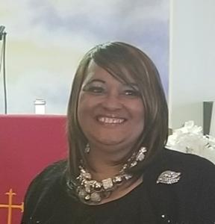

Yulanda is a former Day Care Provider, Cleveland Clinic employee, and executive secretary. She served as Director of the UMBDA YOUTH Ministry of the Northern region of Ohio for over 15 years. She has served as an Adult and Youth Choir Director at Memorial M. Baptist Church. Yulanda also serves as Goodwill Ambassador – (visiting the sick, bereaved and elderly) at Memorial M. Baptist Church. Yulanda conducts annual warm hats and glove campaigns for the Greater Cleveland area through the Volunteers for Cleveland Organization. She currently serves as Vice-President of the Women’s Ministry of The United Missionary Baptist State Convention of Ohio, is involved in community outreach (feeding the homeless, warm blanket distribution, and collecting personal items for the Women’s’ homeless shelter and the sick and shut-in).

Yulanda is a wife, mother of two, grandmother of four, the youngest of four siblings and is a God-fearing woman who lives by the Word of God. She became affiliated with M-PAC Cleveland because her nephew, Andre Brown, was a victim of gun violence, a tragic event that has turned her family’s lives upside down. Yulanda has dedicated herself to doing everything she can to help put gun violence to an end and help other families deal with what has become her family’s new norm on life.

